Unity Bootcamp - Creating a 2D Game

Part 4 - Start and End screens

# 

# Game Title

Create a new scene, then add a *UI > Text GameObject* to the scene in the hierarchy,

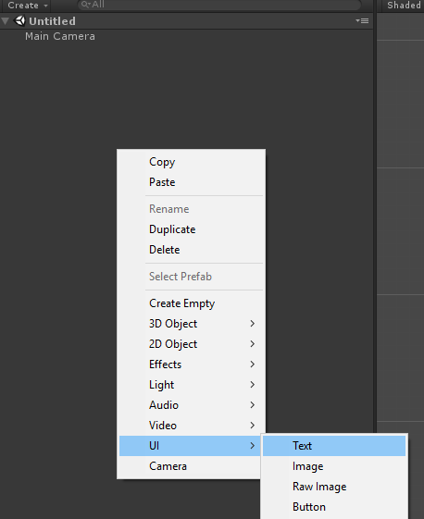

Double click on your new *Text* GameObject in the hierarchy to center the scene camera on it. In the scene, move the text around, and use the values in the *Text* component on the Game Object to create an exciting, eye-catching, original, marketable, title for your platformer game.

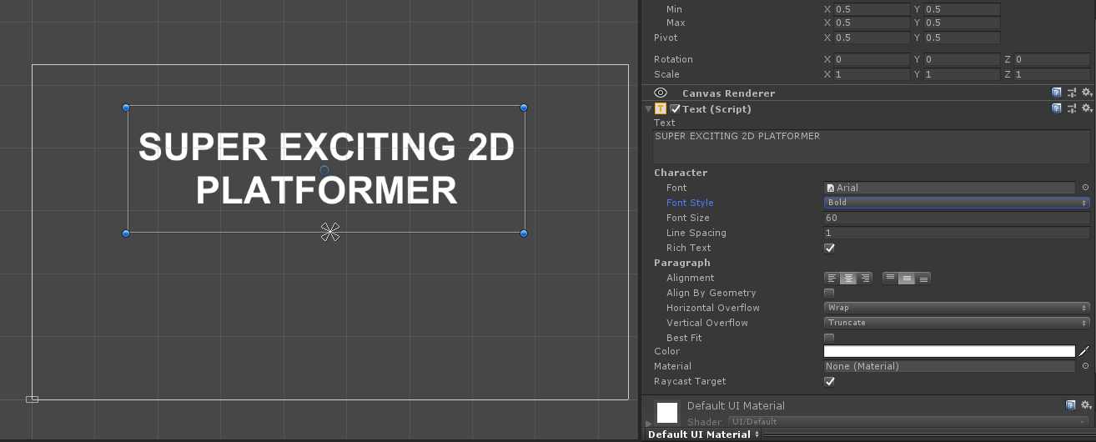

*Tip:* make the text bold to make it super impressive.

# Script

Import the *Menu* script into the project. Create an empty GameObject, call it *Menu Script* and Add the newly imported script as a component of it.

This script will handle the code triggered by the buttons in the next section.

# Start button

It’s time to create a start button, like you did with the *Text* GameObject, create a new *Button* GameObject in the hierarchy (*UI > Button*).

Move the button around and make it look somewhat presentable. To edit the text of the button, expand the *Button* Game Object in the hierarchy, there’s a *Text* GameObject as a child with a Text Component attached to it.

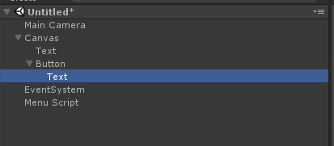

Once you’re happy with how the button looks, find the ***On Click ()*** section of the *Button* component on the *Button* GameObject.

* Press the + button, then drag the Menu Script into the Object field.
* Press the No Function dropdown.
* Press StartGame() via the Menu dropdown.

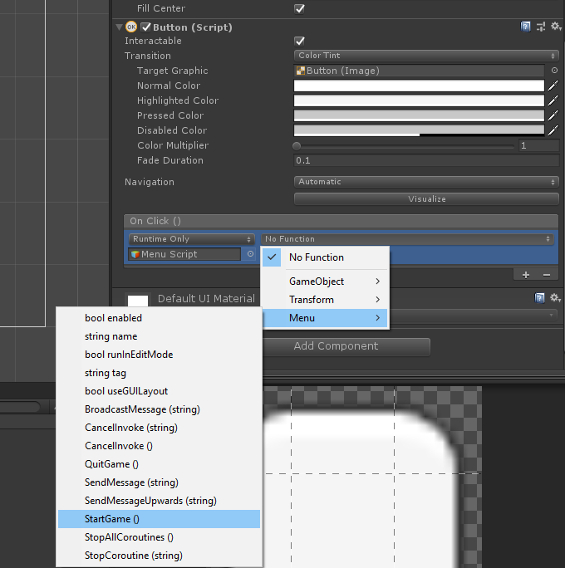

This will trigger the loading of the next level when the button is clicked on.

# 

# 

# Exit Button

It’s important to have an exit button for people get bored of playing your game. Copy the Start Button in the hierarchy, move it around in the scene. Change the text in it’s child to *Exit* and then change the OnClick() function to *Menu > QuitGame()* instead of *Start Game*.

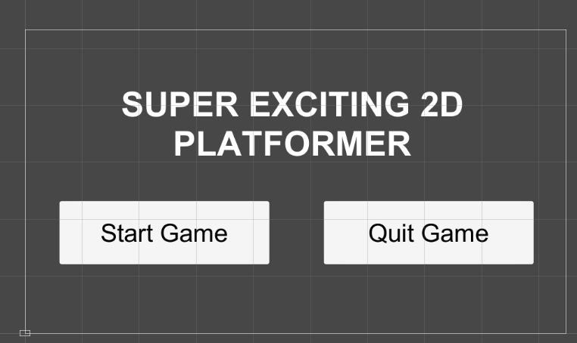

# Save your Scene

Save the scene, call it something like *Menu*. Then go into your build settings, press *Add Active Scenes*, then move the *Menu* scene to the very first place in the list (before *Level1* and *Level2*).

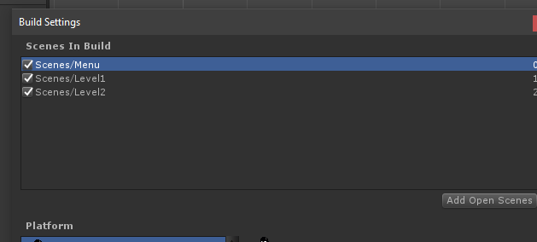

# Test again!

Now if you play your game, you will be able to press *Start Game* and play your game. You’ll notice if you run out of lives it will go back to the menu. The Quit button won’t work in Editor, but if you render your game it will close the game when you press it.

# End Screen

Create a new scene, if you wanna be lazy you could duplicate the Menu scene (Ctrl + D) and rename it to ‘End Screen’.

Import the ***EndScreen*** script. Create an Empty GameObject and add the *EndScreen* component to it, or if you copied the *Menu* scene, replace the *Menu* component on the *Menu Script* GameObject.

Build the UI for an endscreen with a *Back to Menu* button and a *Quit Game* Button.

Just like the the menu screen, we’re going to setup on *On Click()* section of the buttons, this time to reference the *EndScreen* script. Running the code *ResetGame()* and *QuitGame()*.

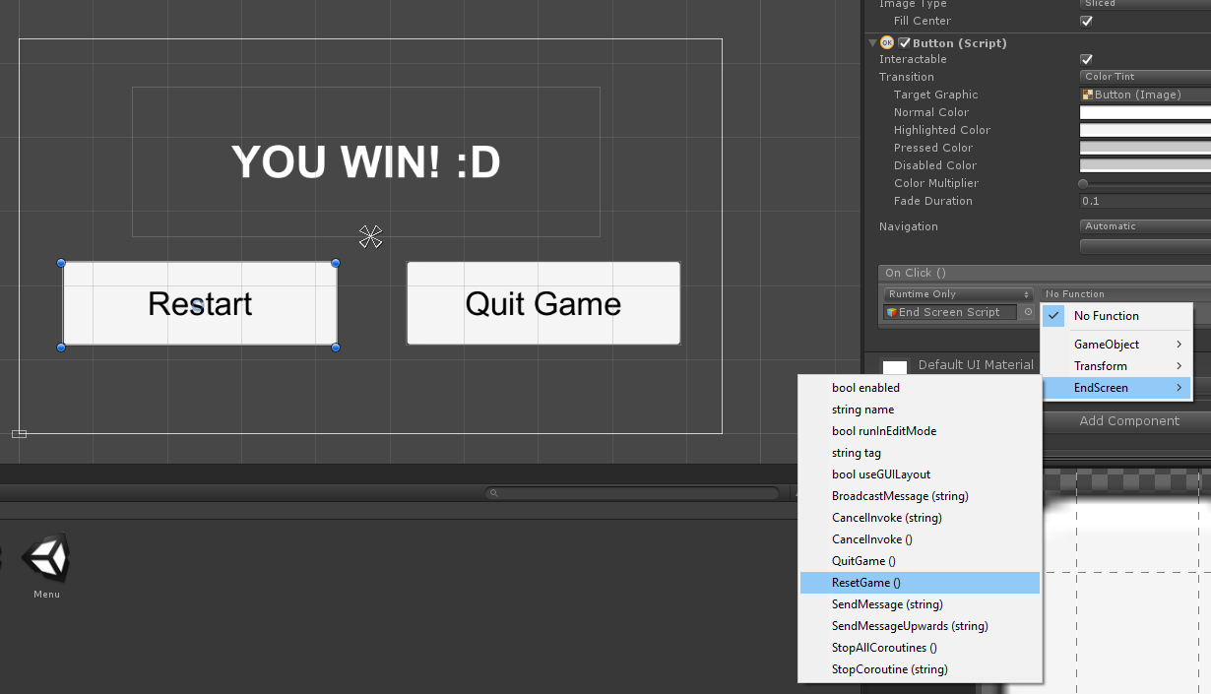

# Save your Scene

Save the scene, call it *End Screen*. This time in the *Build Settings* we’re going to put it as the last level.

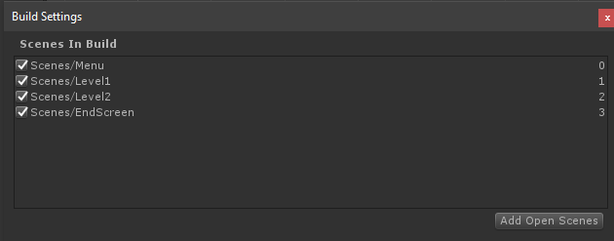

# Playtesting

Now play test your game (make sure to load the menu scene before pressing play). The game should be playable from the menu all the way to the end screen.